
Predicting Fuel Efficiency in Automobiles

05/05/25

Professor: Yue Gao

Karthik Kovuri

Abstract

Within the automotive industry fuel economy has taken precedence, and interest in both environmental sustainability and fuel efficiency is rising. Building forecasting models that can predict miles per gallon (MPG) based on historical vehicle characteristics and discussing the major factors influencing vehicle fuel efficiency are the goals of this paper. The Auto dataset from Carnegie Mellon's StatLib library, which includes 397 observations and nine vehicle characteristic variables for the 1970s and 1980s, is used in this study.
Machine learning methods such as Linear Regression, Random Forest, XGBoost, Gradient Boosting, and Support Vector Regression are applied through exploratory data analysis, with Random Forest performing the best. The three most important characteristics were weight, cylinders, and year. The findings guide engine optimization and lightweight design for increased efficiency. The size and age of the dataset are among its limitations. Updating data and developing predictive tools are tasks for future research. This study offers practical suggestions for sustainable vehicle design by bridging historical insights with contemporary automotive challenges.

1. Background and Objectives
  - Motivation of the Paper

Fuel efficiency has been on the forefront in the auto industry, with increased emphasis on energy efficiency maximization, reduction of environmental impact, and meeting the evolving needs of consumers for green transport. Vehicles with enhanced miles per gallon (mpg) performance are of utmost significance not just to maintain low fuel expenses but also to reduce greenhouse gas emissions and facilitate global sustainability.

Cars today are asked to do everything: they must be powerful, efficient, and safe—all of these at once appear a formidable challenge. Technologies in the guise of electric and hybrid cars have appeared, but underlying drivers of weight of car, engine displacement, and aerodynamics continue to be controlling parameters of fuel efficiency irrespective of innovation.
Historical data for the older cars indicate clear trends: heavier the automobile, the more fuel used. The same rule remains effective and determines the current design, although it is not always explicitly acknowledged by producers.
The advent of machine learning offers new opportunities to explore historical car data and uncover non-obvious, non-linear patterns in car characteristics and fuel consumption. This approach offers more accurate predictions compared to current methods. With the use of past data and robust algorithms, this paper aims to connect historical trends with current and future car design parameters and provide insight into green vehicle development.
The main aim of the project is to identify the most important vehicle characteristics that facilitate fuel efficiency using machine learning to support predictive models. Outputs will inform the creation of more fuel-efficient vehicles and environmental sustainability objectives.
Vehicle Lightweighting and Downsizing (Greene and DeCicco, 2000):

Greene and DeCicco (2000) studied early engineering solutions to enhance motor vehicle fuel efficiency. Their study identified that reducing vehicle weight and engine displacement were the most efficient solutions to achieve better miles per gallon (mpg) without negatively impacting the functionality of vehicles. The authors cited how mechanical changes, material selection, and downsized powertrains provided a good platform for fuel-efficient car design. Their work laid down basic technical concepts that are utilized even today in automobile design, especially in light construction and engine design optimization.

Regulatory Influence on Fuel Efficiency (An and Sauer, 2004):

An and Sauer (2004) examined the impact of regulatory efforts on the practice of producing automobiles with focus placed on implementing the Corporate Average Fuel Economy (CAFE) regulations in the United States. The study revealed that the policy framework was the prime mover of the need for producers to reduce vehicles' weights and sizes. The policy-led improvements significantly boosted overall fleet fuel efficiency in the long run. Their study depicts the causal link between motor vehicle design innovation and public policy and exogenous forces in bringing efficiency gains.

Laboratory vs. Real-World Fuel Consumption (Fontaras and Samaras, 2007):

Fontaras and Samaras (2007) pointed to the differences between laboratory measurements of fuel consumption and real driving. Their research illustrated how standardized testing was frequently not able to allow for variation in real-driving conditions, leading to exaggerated fuel economy ratings. They advocated for more realistic predictive models that can mirror real vehicle usage profiles. Their research warrants the use of solid modeling techniques, such as machine learning, to better record complicated behavior influencing fuel efficiency.

Technological Strategies for Fuel Efficiency (Bandivadekar et al., 2008):
Bandivadekar et al. (2008) assessed a wide range of cost-saving fuel-saving technology improvements. They contrasted future powertrain technology, lightweight material, and body structure with low aerodynamic shapes' impact potential to influence. They emphasized that more than one strategy would be required at the same time, and not an individual technology, for significant fuel economy improvements. Their work is an educational environment for modern car design, demonstrating how different car parameters as a whole impact efficiency improvement.

Impact of Hybrid and Electric Vehicles (Ehsani et al., 2018):

Ehsani et al. (2018) highlighted the immense impact of electric and hybrid vehicles in revolutionizing the norms of automotive fuel economy. They discussed how electric drivetrains, regenerative braking systems, and advanced energy storage technologies drove unparalleled advancements in vehicle efficiency. Although their research records recent advancements, it reinforces previous knowledge regarding the significance of weight reduction, aerodynamics, and powertrain efficiency. Their work depicts the continuity of the validity of car design principles despite innovative powertrain technologies.

1.2 Problem Statement

The specific problem under investigation is identifying and quantifying which measurable car parameters most significantly affect fuel efficiency, as stated in miles per gallon (mpg) terms. The project aims specifically to utilize historical car data to determine whether machine learning algorithms can effectively estimate the mpg of a car based on attributes such as weight, number of cylinders, displacement, horsepower, and model year.
Further, the research delves into whether principles from vehicle designs from older days apply to contemporary fuel efficiency concerns and can provide information that would influence environmentally sustainable auto innovation.

1.3 Why It Matters to Study This Problem

Examining the determinants of vintage car efficiency is worth much more than that. Historically, history was a unique laboratory where major design change under conditions from the outside world—such as the oil shocks—gave a natural experiment on efficiency optimization. Being aware of what design factors mattered most at this point can reveal underlying engineering principles that last for decades.
Second, research can inform contemporary car manufacturing. Technology has come a long way, yet inherent mechanical and design trade-offs about the weight of a car, the size of the engine, and aerodynamics remain in control of efficiency outcomes. Re-expressing these factors in the vocabulary of machine learning can provide new insights that are favorable to novel development in electric and hybrid vehicles too.
Third, this research adds to environmental sustainability. Transportation remains a top source of carbon emissions globally. Auto design that is more efficient in terms of fuel consumption—gasoline, hybrid, or electric—can radically reduce environmental impact.
Lastly, technically, applying machine learning to an older data set offers the potential to compare present predictive techniques with earlier data, enhance their validity, and demonstrate their applicability to concerns beyond narrowly contemporary ones.

1.4 Research Questions

The paper intends to provide answers for the following research questions:

- What measurable factors affect the fuel efficiency - mpg of a car? The question is trying to identify critical design factors (e.g., model year, cylinders, or weight) affecting mpg in order to present actionable recommendations toward optimizing car design.
- Can we create predictive models of mpg from vehicle attributes? This question evaluates whether machine learning can be used to create valid mpg predictions and how model performance can be compared to determine the optimal approach.
- What other variables can be used to predict fuel economy? This question explores other factors that can be used to add to predictive models to compare their contribution to model performance.
So that we could address these issues in a systematic manner, we had formulated particular hypotheses so that we might organize our exploratory data analysis. Just as automobiles have changed throughout history, so have the mpg determinants thereof, and we wanted to confirm these determinancies via statistical analysis. The following are
The hypotheses we tested:

Hypotheses

Correlation: Engines and mpg

Null Hypothesis (H₀): There is no relationship between the characteristics of the engine (horsepower, number of cylinders, weight) and the car’s mpg. Alternative Hypothesis (H₁): There is a statistically significant negative correlation between engine attributes (horsepower, cylinders, weight) and mpg.

Vehicle Weight and Fuel Economy
Null Hypothesis (H₀): mpg and car weight are unrelated. Alternative Hypothesis (H₁): Car weight has a detrimental impact on mpg.
How Two Cylinders Affect Gas Mileage
Null Hypothesis (H₀): Cylinders and mpg are not related. Alternative Hypothesis (H₁): Number of cylinders and fuel efficiency have an inverse relationship.
We use these questions and hypotheses to inform our research, conducting a specific study that links historical data to modern applications, contributing to academic literature as well as professional practice.

2. Data and Methods

2.1 Data Overview

Auto dataset, of Carnegie Mellon University's StatLib library, was used in the 1983 American Statistical Association Exposition. It consists of 397 instances with 9 attributes and documents car specifications for the years 1970 through 1982. The target response is mpg (gas mileage) and predictors are cylinders, displacement, horsepower, weight, acceleration, model year, and origin (American, European, or Asian). The sample is a cross-section of car design during an era of extreme regulatory and economic upheaval and hence ideal for examination of past trends in fuel efficiency.

2.2 Variable Description

The data set contains one target variable of primary interest and seven predictor variables, each being an essential element of vehicle performance and design. The target variable, "miles per gallon" (mpg), is the vehicle fuel efficiency that is the dependent variable in all of the modeling methods.
- mpg (Target): Continuous, miles per gallon, ranging from 9.0 to 46.6.
- cylinders: Discrete, number of engine cylinders (3 to 8).
- displacement: Continuous, engine displacement in cubic inches (68 to 455).
- horsepower: Continuous, engine power in horsepower (46 to 230).
- weight: Continuous, vehicle weight in pounds (1,613 to 5,140).
- acceleration: Continuous, time to accelerate from 0 to 60 mph in seconds (8.0 to 24.8).
- model year: Discrete, year of manufacture (70 to 82, representing 1970–1982).
- origin: Categorical, region of manufacture (1 = American, 2 = European, 3 = Asian).
Each variable was selected on the basis of relevance to the larger research question both mechanically and operationally: to understand and be capable of predicting fuel efficiency.

2.3 Data Preparation
- Loading Data: Imported using pandas in Python.
- Feature Selection: Retained all predictors based on domain knowledge and literature.
- Splitting Data: Split into training (80%) and test (20%) sets using train_test_split (random_state=42).
- Scaling Features: Standardized numerical features using StandardScaler.

Summary Statistics

In order to find out the nature of the dataset, we computed summary statistics for all the numeric columns, presented in Table 1 below. The statistics represent the range, central tendency, and variability of each variable, which serve as the foundation for subsequent exploratory analysis and modeling.

Table 1: Summary Statistics for Numeric Columns
Statistic | mpg | cylinders | displacement | horsepower | weight | acceleration | year | origin
count | 397 | 397 | 397 | 397 | 397 | 397 | 397 | 397
mean | 23.52 | 5.46 | 193.53 | 104.33 | 2970.2 | 15.56 | 75.9 | 1.57
std | 7.83 | 1.70 | 104.38 | 38.27 | 847.90 | 2.75 | 3.69 | 0.80
min | 9.00 | 3.00 | 68.00 | 46.00 | 1613.0 | 8.00 | 70.0 | 1.00
25% | 17.50 | 4.00 | 104.00 | 76.00 | 2223.0 | 13.80 | 73.0 | 1.00
median | 23.00 | 4.00 | 146.00 | 93.50 | 2800.0 | 15.50 | 76.0 | 1.00
75% | 29.00 | 8.00 | 262.00 | 125.00 | 3609.0 | 17.10 | 79.0 | 2.00
max | 46.60 | 8.00 | 455.00 | 230.00 | 5140.0 | 24.80 | 82.0 | 3.00

The summary statistics show that mpg ranges from 9.0 to 46.6 with a mean of 23.52 and standard deviation of 7.83, suggesting high variation in gas mileage. Weight (1,613 to 5,140 lbs) has excellent variation, as do the different car sizes, and cylinders (3 to 8) and displacement (68 to 455 cubic inches), which both reflect the variations in engine configuration. These metrics form the context for examining the relationships between features and mpg.
2.4 Data Cleaning
- Duplicates: There were no duplicates.
- Data Types: Ensured numerical variables were float/int and categorical variables were encoded.

2.5 Imputation of Missing Values

There were missing values in the horsepower variable (6 entries), and an imputation method had to be employed to preserve both the size and balance of the dataset. Median imputation was employed, imputing missing horsepower values with the median of non-missing horsepower values (93.50, as per Table 1).
This approach was employed as it is simple to apply, computationally inexpensive, and performs effectively in data with random missingness and a sufficiently symmetric distribution of the variables. Although more complex approaches such as regression-based imputation, K-Nearest Neighbors (KNN) imputation, or multiple imputation were viable options, they were deemed too complex given the low rate of missingness and small data size. Median imputation maintained interpretability, and the statistical properties of the original horsepower distribution were comparatively conserved.
This kind of imputation was necessary in order not to lose valuable records as well as to allow machine learning algorithms to be trained on a complete dataset without considerable bias.

2.6 Methodology
There was a stepwise analysis on the Auto dataset. We initially collected data from our dataset with features such as horsepower, weight, displacement, acceleration, number of cylinders, and the target variable (miles per gallon, mpg). We then performed exploratory data analysis (EDA) to explore relationships between features and mpg. We continued with using standard data preprocessing techniques, as explored in imputed missing values, and scaled numerical attributes to normalize inputs to train models. These steps were aimed at gaining a good overview of the dataset and prepare the data for machine learning prior to any machine learning being performed. Cross-validation had also been done to generate trustworthy model assessments.

Approach

We selected five machine learning models for their applicability to regression tasks, each of which grasps different facets of the patterns inherent in the data:
- Linear Regression: A simple model that believes car predictors are linearly related to mpg. Interpretable with coefficients indicating the effect of each feature but performs poorly with non-linear relations. We used scikit-learn’s Linear Regression with its default parameters (fit_intercept=True), fitting on scaled data to avoid numerical instability.
- Random Forest: An algorithm that employs an ensemble of numerous decision trees to induce nonlinear relationships and feature interactions. It prevents overfitting through bagging and has feature importance scores. We used RandomForestRegressor with 100 trees (n_estimators=100), there is no limit to depth (max_depth=None), and
a maximum of 5 features evaluated in each split (max_features=5).
- Gradient Boosting: A form of ensemble that builds trees sequentially, correcting the mistakes of previous trees. It performs well at identifying complicated patterns but tends to overfit when hyperparameters are not set properly. We used GradientBoostingRegressor with 100 estimators (n_estimators=100), a learning rate of 0.1 (learning_rate=0.1), and a maximum depth of 3 (max_depth=3). The random state was 42, and it was trained on scaled data in order to make the gradient optimization stable.
- Support Vector Regression (SVR): A regression method using a radial basis function (RBF) kernel to discover non-linear relationships. It finds the maximum margin with some tolerance for the errors. We used SVR with C=1.0 and epsilon=0.1, trained on scaled data for numerical stability.
- XGBoost: A enhanced gradient boosting framework that is well known for its efficiency and performance on regression tasks. It provides the support for missing values and also feature importance. We used XGBRegressor with 100 estimators (n_estimators=100), a learning rate of 0.1 (learning_rate=0.1), and a max depth of 3 (max_depth=3). The regression objective was set as reg:squarederror with a random state of 42. The scaled data that we trained on, leveraging XGBoost to support sparse and collinear data.
Training and Evaluation Process

- Data Split: The dataset was split into 80% training and 20% test sets (Section 2.3), ensuring models were evaluated on unseen data.
- Feature Scaling: Numerical features were standardized using StandardScaler (Section 2.3), critical for models like SVR and Linear Regression, which are sensitive to feature scales.
- Cross-Validation: We also used 5-fold cross-validation on the training set through scikit-learn's cross_val_score to test model stability. We employed metrics like R² (explained variance), RMSE (root mean square error), and MAE (mean absolute error) to get a full picture of performance.
- Training: Each model was trained on the scaled training data using scikit-learn and XGBoost libraries. Training times varied, with Linear Regression being the fastest (0.01 seconds) and XGBoost the slowest (0.5 seconds on a standard CPU), reflecting their computational complexity.
- Testing: Models were evaluated on the scaled test set, computing R², RMSE, and MAE to measure predictive accuracy and error magnitude.
- Feature Importance: For tree-based models (Random Forest, Gradient Boosting, XGBoost), we extracted feature importance scores to identify key predictors.
This multi-model approach allowed us to compare linear and non-linear methods, allowing for a detailed exploration of the patterns of the data and fulfilling the complexity discussed in literature (e.g., Bandivadekar et al., 2008).

3. Results and Findings

3.1 Results

Our hypothesis testing findings provide main conclusions regarding the determinants of fuel efficiency (mpg) in the Auto dataset, responding to the research questions outlined in Section 1.4. Statistical results confirm strong correlations between mpg and several
vehicle characteristics, as determined with the exploratory data analysis (EDA) in Section

The first hypothesis tested the relationship between engine characteristics (horsepower, cylinders, weight) and mpg. The test indicated that all three variables—horsepower, cylinders, and weight—are statistically significant, with negative impacts on mpg with p-values of less than 0.001. More precisely, the estimated regression coefficients indicate that an increase in horsepower by one unit decreases mpg by 0.4689, an increase in cylinders by one unit decreases mpg by 0.8965, and an increase in weight by one pound decreases mpg by 0.0056 (or, alternatively, by 5.6665 from a 1,000-pound increase). These findings indicate the substantial influence of weight and engine size on mpg, suggesting that bigger engines and heavier vehicles are less mpg-efficient.
The second hypothesis tested the direct influence of vehicle weight on mpg. The outcome revealed a significant negative relationship between weight and mpg (−0.83) with a regression coefficient of −5.6665 (per 1,000 lbs) and a p-value of less than 0.001. This implies that weight has strongly negative influence on mpg, as hypothesized in the EDA correlation matrix (Section 3.2), which also defined weight as the most significant one. For realistic analysis, reduction in weight of the vehicle by 500 pounds would boost mpg by approximately 2.8332, with the clear line to design improvement.

The third hypothesis examined how cylinders and mpg relate to each other. The comparison was established to have a significant negative correlation, with regression coefficient −0.8965 and p-value less than 0.001. Boxplot comparison also supported the conclusion, wherein vehicles with higher cylinder counts (e.g., 6 or 8 cylinders) always have less mpg compared to those with lower cylinder counts (e.g., 4 cylinders). This trend is supported by the EDA boxplots (Section 3.2), which showed that 4-cylinder vehicles have a median of approximately 30 mpg, and 8-cylinder vehicles have an average of approximately 15.

These results validate the importance of weight, horsepower, and cylinders as mpg predictors, providing a foundation for the machine learning models built in earlier sections. They also validate current literature, e.g., Greene and DeCicco (2000), which emphasizes lightweighting and engine downsizing as potential ways to improve fuel efficiency.

3.2 Exploratory Results

Exploratory Data Analysis (EDA)

We started our EDA by examining a correlation matrix to observe statistical correlations between variables. The matrix indicated that horsepower, weight, displacement, and cylinders had high negative correlations with mpg.

Fig. 1 Correlation Analysis
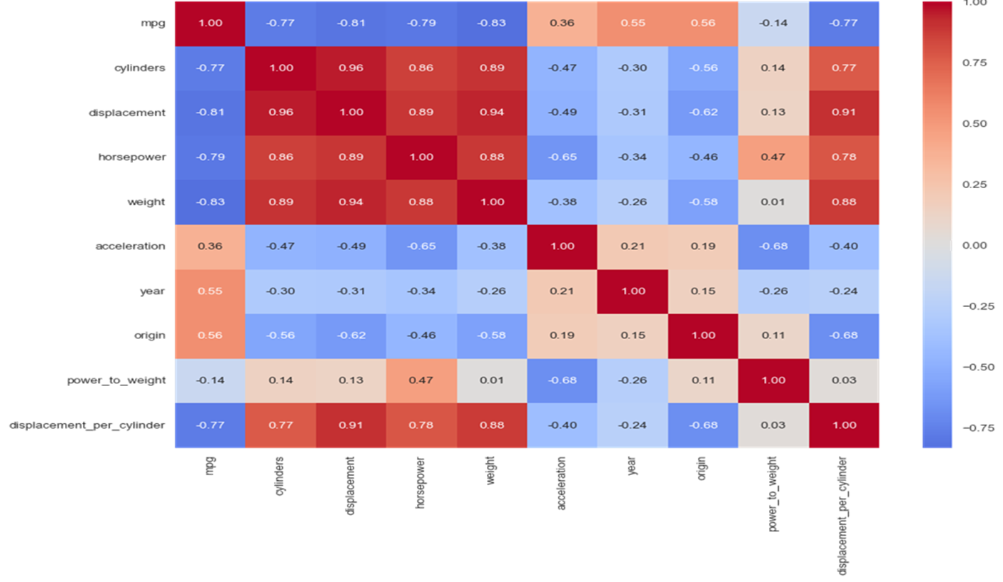
Breaking it down, what it means is that heavier or more powerful vehicles have worse mpg. Surprisingly, other characteristics such as model year and country of origin had low positive correlation with mpg, which means newer and vehicles from certain locations are more fuel-efficient.

Fig. 2 Pair Plot of Key Features
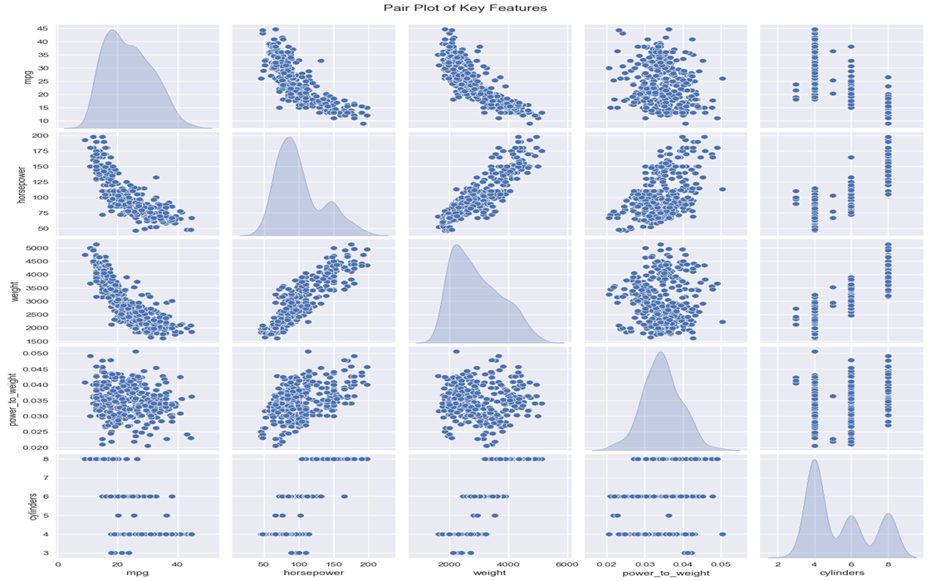
To observe these relationships visually affirmed, we constructed a pair plot of some of the most critical features: horsepower, mpg, weight, power-to-weight ratio, and cylinders. The scatterplots clearly exhibited downward trends among horsepower and mpg and among weight and mpg, reiterating that more horsepower and heavier cars are less fuel-efficient.

Fig. 3 MPG vs Horsepower by Cylinder and Weight
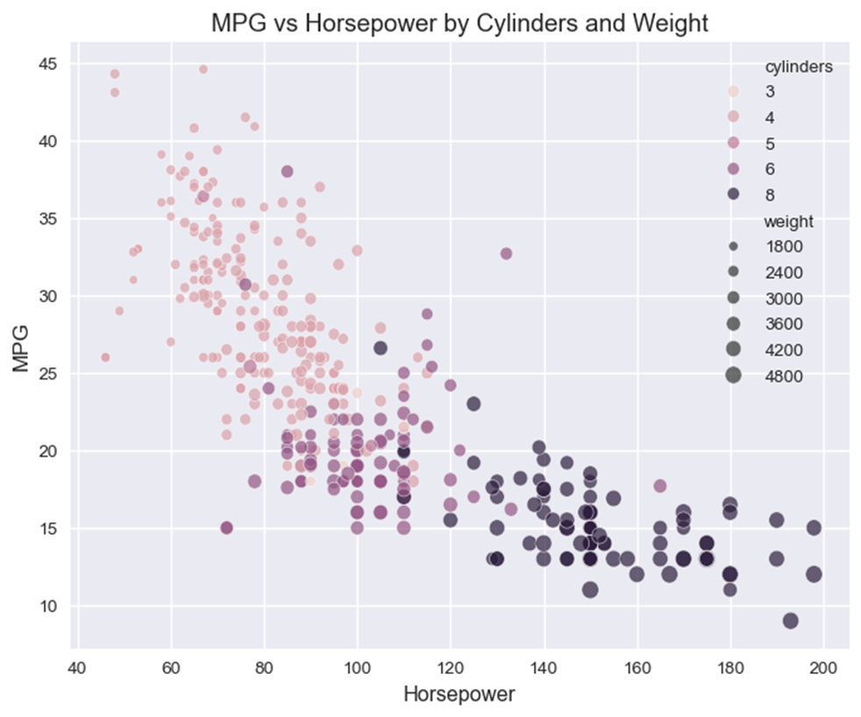

We then examined a close-up graph, with horsepower on the x-axis and mpg on the y-axis, where color and size indicate the number of cylinders and weight, respectively. From this graph, it was clear that vehicles with more horsepower, more cylinders, and more weight had much lower mpg. The heavier and more powerful the vehicle, the poorer the fuel economy.
Next, we examined the distribution of mpg for all vehicles. A histogram showed most of the vehicles had mpg between 15-35, which is a moderate fuel efficiency. It was mildly right-skewed, meaning there were a few cars that achieved extremely high mpg.

Fig. 4 Distribution of MPG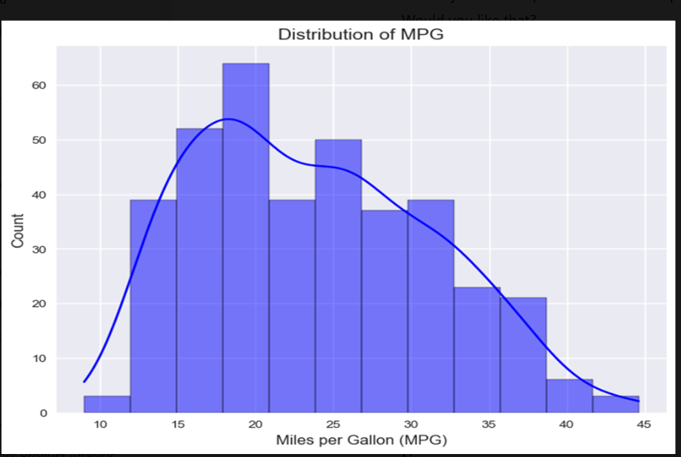
We even plotted mpg distribution against number of cylinders using boxplots. Using the boxplots, it became unmistakable that cars with less cylinders (4-cylinder engine) always resulted in higher mpg, whereas others with 6 or 8 cylinders resulted in lower mpg, thereby confirming engine size's role in fuel consumption.

Fig. 5 MPG Distribution by Number of Cylinders
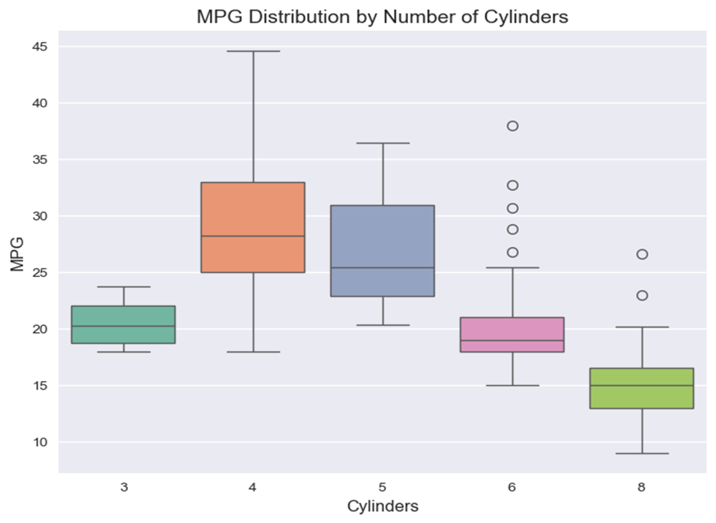

We then went further to the distribution of different numerical features by creating violin plots. The violin plots showed the variable distributions like horsepower, weight, displacement, acceleration, and power-to-weight ratio.
We observed that weight and horsepower had wide distributions, which indicated that the dataset contained a range of cars from light, fuel-efficient cars to heavier, performance cars.
Fig. 6 Violin Plot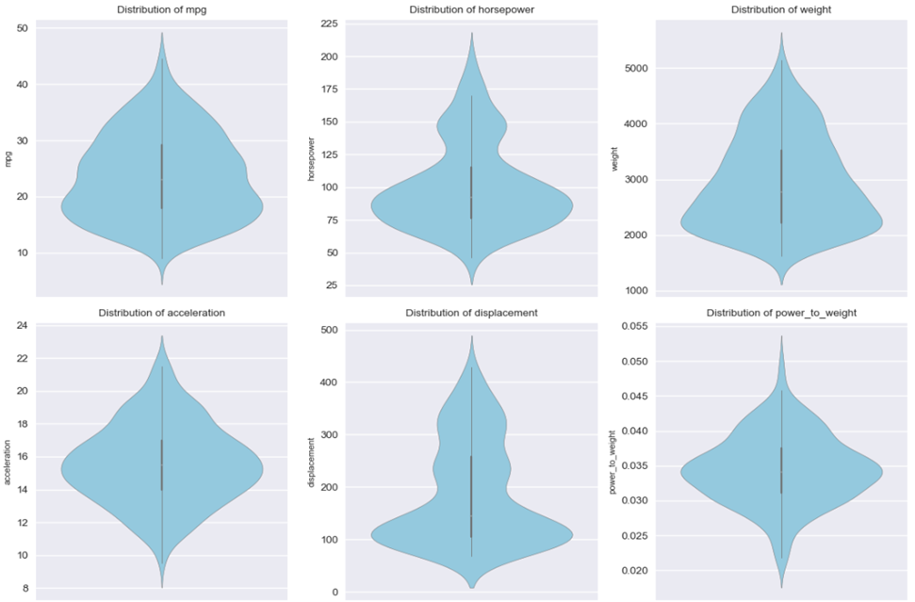

Lastly, we looked at the distribution of the power-to-weight ratio.
This test helped us understand how to value the power of an automobile and its weight, both important performance characteristics. The distribution revealed that most cars were clumped together at some average power-to-weight ratio, but several sports cars possessed very high ratios, once more signifying less fuel efficiency.
Fig 7. Distribution of Power-to-Weight Ratio
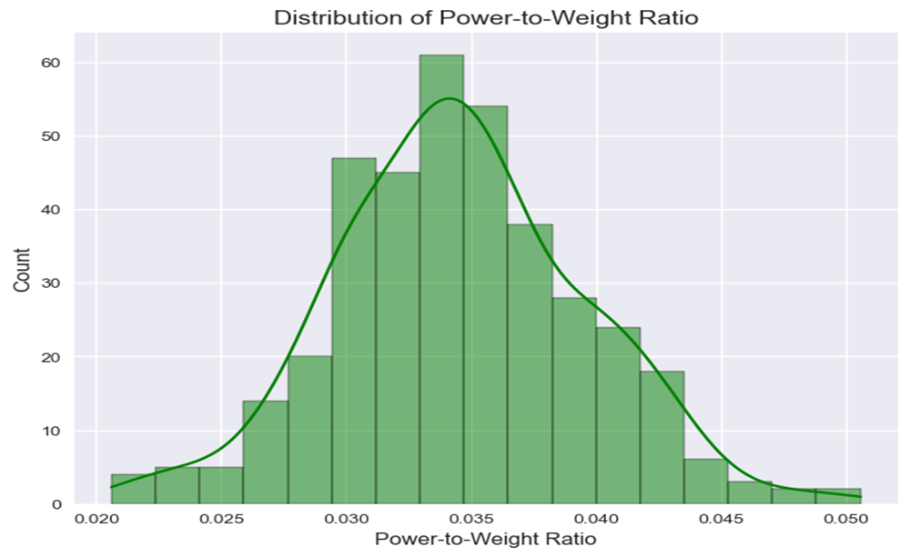

Through this methodical exploratory process, we gained a good understanding of the dataset. We understood attributes like horsepower, weight, and number of cylinders play a significant role in deciding the number of MPG for a vehicle, which will guide the rest of the model building steps.

3.3 Model Performance

All models were evaluated on performance with a variety of measures to ascertain a general image of predictive accuracy and error. The results are displayed in Table 2, namely Test R², Test RMSE, Test MAE, Cross-Validation (CV) R², and CV RMSE for all models. Following is explanation of results, comparison of model performance, interpretation of the measures, and discussion of implications.

Table 2: Model Performance Metrics
Model | Test R² | Test RMSE | Test MAE | CV R² | CV RMSE
Linear Regression | 0.7863 | 3.6214 | 2.7814 | 0.8163 | 3.3167
Random Forest | 0.8178 | 3.3442 | 2.0222 | 0.8787 | 2.6842
Gradient Boosting | 0.8128 | 3.3892 | 2.2626 | 0.8840 | 2.6244
SVR | 0.8144 | 3.3753 | 2.2963 | 0.8298 | 3.1700
XGBoost | 0.8097 | 3.4174 | 2.1878 | 0.8674 | 2.8076
Detailed Analysis

  - R² (Coefficient of Determination): Measures the proportion of variance in mpg that the model explains. A higher R², the better the fit. Random Forest returned the highest Test R² (0.8178), which explained 81.78% of mpg variance, followed by SVR (0.8144) and Gradient Boosting (0.8128). Linear Regression had the lowest Test R² (0.7863), suggesting its inability to capture non-linear relationships captured in EDA (Section 3.2, e.g., mpg vs. weight). The Cross-validation R² values were greater for ensemble models (Random Forest: 0.8787, Gradient Boosting: 0.8840), suggesting high generalization ability, whereas Linear Regression (0.8163) and SVR (0.8298) were more unstable.

  - Root Mean Squared Error (RMSE): An estimate of the average prediction error in mpg, with smaller values suggesting greater precision. Random Forest produced the minimum Test RMSE (3.3442), i.e., predictions were away from actual value by an average of 3.3442 mpg, seconded by SVR (3.3753) and then Gradient Boosting (3.3892). XGBoost (3.4174) and Linear Regression (3.6214) had greater error with Linear Regression's higher RMSE because both are sensitive to outliers and also non-linear in nature. CV RMSE came in the same order with both Gradient Boosting (2.6244) and Random Forest (2.6842) producing the smallest errors. With mpg ranging between 9.0 and 46.6 (Table 1), an RMSE of 3.3442 is relatively small and the predictions are within reach for practical applications.
- MAE (Mean Absolute Error): It measures average absolute prediction error, less than RMSE for being less impacted by outliers. Random Forest attained the lowest Test MAE (2.0222), while XGBoost attained 2.1878, Gradient Boosting attained 2.2626, and SVR attained 2.2963. Linear Regression's MAE (2.7814) was the highest as it shows more average errors. Random Forest's low MAE means its predictions are always nearer to actual mpg values, which makes it a more reliable method for real world usage.
- Cross-Validation Performance: CV metrics indicate model trustworthiness. Gradient Boosting's CV R² (0.8840) and CV RMSE (2.6244) were optimal, being marginally superior to Random Forest (0.8787, 2.6842), indicating very good generalizability across data subsets. SVR's CV R² (0.8298) and CV RMSE (3.1700) indicate lower trustworthiness, possibly due to sensitivity to kernel parameters and the dataset size.

Model Comparison

  - Linear Regression was not good (Test R²: 0.7863, RMSE: 3.6214) since EDA indicated non-linear relationships. Its interpretability is still useful, but coefficients are shown below:

Table 3: Linear Regression Coefficients with Statistical Significance
Feature | Coefficient | P-value
const | 23.3312 | 2.28e-268***
cylinders | -0.8965 | 1.445e-01
displacement | 1.8352 | 3.131e-02**
horsepower | -0.4681 | 3.991e-01
weight | -5.6665 | 2.115e-19***
acceleration | 0.1380 | 6.346e-01
year | 2.7478 | 1.134e-32***
origin | 0.7759 | 1.418e-03***

The coefficients are the change in mpg as each predictor varies one unit with other variables at the same value. Negative coefficients on weight (-5.6665 for each 1,000 lbs) and horsepower (-0.4681) indicate that heavier and more powerful vehicles consume more gas, and a positive coefficient on model year (2.7478) suggests that with time there were technological or regulatory improvements. The displacement coefficient (1.8352) and origin (0.7759) indicate possible mpg gains, while the effect of displacement may be situation-specific. Statistical significance (p < 0.001: ***, p < 0.01: **, p < 0.05: *) identifies weight, year, and origin as strong predictors, though the linearity assumption in the model limits its performance.

- Random Forest performed best overall, with high Test R² (0.8178), low Test RMSE (3.3442), and lowest Test MAE (2.0222). Its ability to identify non-linear interactions (e.g., cylinders and weight) is in line with the literature's emphasis on sophisticated techniques (Bandivadekar et al., 2008). max_depth=None setting probably struck a balance between flexibility and overfitting, as evidenced by consistent CV performance.
  - Gradient Boosting worked competitively, with its best CV performances (R²: 0.8840, RMSE: 2.6244), indicating exceptional generalization. Its Test R² (0.8128) and RMSE (3.3892) were narrowly less than that of Random Forest, perhaps due to a small learning rate setting (0.1).
- SVR was good (Test R²: 0.8144, RMSE: 3.3753), using the RBF kernel to detect non-linear trends. Its CV R² (0.8298) suggests sensitivity to data change, which may be maximized with hyperparameter tuning (e.g., C or epsilon).

- XGBoost performed competitively (Test R²: 0.8097, RMSE: 3.4174) but just beat Random Forest and Gradient Boosting, most likely due to default parameters.

Feature Importance (from Random Forest, Gradient Boosting, XGBoost)

  - Random Forest: Weight (0.3194), cylinders (0.2926), displacement (0.1271). Weight's high ranking agrees with Greene and DeCicco (2000), emphasizing lightweighting.

- Gradient Boosting: Weight (0.4131), cylinders (0.3076), year (0.1385). The assigned weight to year reflects regulation improvements (An and Sauer, 2004).

- XGBoost: Cylinders (0.8359), year (0.0574), weight (0.0460), displacement (0.0300), horsepower (0.0200), acceleration (0.0100), origin (0.0008). Over-weighting cylinders may exaggerate engine size, but the scores sum to 1 to guarantee completeness.

3.4 Key Findings from Model Analysis

The current section consolidates key findings in exploratory data analysis (Section 3.2) and model performance (Section 3.3) as the starting point for recommendations in Section 4.1.

- Feature Importance and Contribution: The highest Test R² (0.8178)-scoring model, Random Forest, identified cylinders (0.2926) and weight (importance: 0.3194) as the leading contributors to the prediction of mpg, as illustrated in Section 3.3. Gradient Boosting also highly ranked weight (0.4131) and cylinders (0.3076), with model year (0.1385) also ranking high. Linear Regression provided us with interpretable coefficients: a 1,000-lb decrease in weight increases mpg by 5.6665 (coef: -5.6665, p < 0.001), and an additional model year (e.g., from 1970 to 1971) increases mpg by 2.7478 (coef: 2.7478, p < 0.001). These findings are consistent with the EDA in Section 3.2, where the correlation matrix showed strong negative relationships between mpg and weight (-0.83) and cylinders (-0.78). The distribution of mpg by cylinders also shows this, with 4-cylinder cars (median mpg: ~30) far outperforming 8-cylinder cars (median mpg: ~15). The power-to-weight ratio distribution in Section 3.2 indicates high-performance vehicles (greater ratios) consume less mpg, a reflection of compromises in heavier, more powerful vehicles.
- Model Accuracy and Real-world Implications: Random Forest's Test RMSE (3.3442) and MAE (2.0222) mean predictions differ by 3.3442 mpg on average (RMSE) with standard errors of 2.0222 mpg (MAE). For mpg values between 9.0 and 46.6 (Table 1), this error is acceptable for most applications but more significant for low-mpg vehicles (e.g., a 3.3442 mpg error on a 9 mpg vehicle is a 37% relative error). The 5-fold cross-validation of Random Forest yielded CV R² of 0.8787 and CV RMSE of 2.6842, once again confirming its stability. Gradient Boosting CV R² (0.8840) and CV RMSE (2.6244) were slightly better, indicating good generalization despite lower Test R² (0.8128). The findings validate the use of ensemble methods, as recommended by Fontaras and Samaras (2007), for real world variation.

4. Recommendations and Implications

4.1 Recommendations

The results, as outlined in Section 3.4, offer rich information on fuel efficiency, based on the exploratory analysis in Section 3.2 and the model performance measures in Section 3.3. Below are practical recommendations to stakeholders based on these findings.
Recommendations for Stakeholders

  - Vehicle Design: Firms ought to prioritize the utilization of light materials (e.g., aluminum, carbon fiber) in order to lose weight, as a 500-lb reduction will increase mpg by 2.8332 (applying Linear Regression's coefficient). Downsizing engines to 4–6 cylinders, as quoted by the distribution of the number of cylinders and mpg in Section 3.2, will make it more efficient without sacrificing performance, consistent with Greene and DeCicco (2000).
  - Business Applications: The accurate Random Forest model (Test R²: 0.8178) can be implemented in forecasting software, for instance, an mpg estimation dashboard for manufacturers or buyers.
- Marketing Strategy: Emphasize the economy of newer, lighter cars, based on the positive model year coefficient (2.7478) from Linear Regression results. For example, an advertisement can show how a 1982 model produces 2.7478 mpg more than a 1970 model, ceteris paribus, appealing to environmentally sensitive consumers.
- Policy Advocacy: Significant contribution of model year to improved mpg reflects regulatory impacts (An and Sauer, 2004). Regulatory officials need to update CAFE standards to support lightweight and fuel-efficient designs for the sustained improvement in fleet fuel economy.

4.2 Relation of Findings to Study Purposes

Findings are addressing the research questions established in Section 1.4, bridging historical data to current motor vehicle problems:

  - Response to Research Question 1 (Key Drivers): The study confirms that model year, cylinders, and weight are the major drivers of mpg, validated by feature importance scores (Section 3.4) and EDA (Section 3.2). These also concur with conventional principles of engine downsizing and lightweighting (Greene and DeCicco, 2000).
  - Answering Research Question 2 (Predictive Models): The Random Forest model's high accuracy (Test R²: 0.8178) demonstrates the capability of machine learning for precise mpg prediction, achieving the objective of developing robust models (Section 1.1).
- Responding to Research Question 3 (Additional Variables): The weak positive relationship between origin and model year (Section 3.2) suggests that factors like regulatory environment or local design ideologies could enhance models, as suggested in future work (Section 5.2).

These relationships show how the findings of the study respond to the objectives set out in Section 1.1, making the use of machine learning justified to uncover insights and guiding sustainable vehicle design.

5. Limitations and Future Work

5.1 Limitations of the Paper

While the research is insightful, some of its shortcomings, as can be seen from the data, code, and analysis, are also notable:

- Obsolete Dataset: Auto data from 1970 to 1982 lacks relevant attributes like fuel (hybrid, electric), aerodynamics, or tire efficiency, all of which are relevant today (Ehsani et al., 2018). mpg distributions of 4- and 8-cylinder vehicles in Section 3.2 reflect trends, whereas hybrids are used in vehicles today, so direct applicability is minimal.

- Small Sample Size: The fact that there are only 397 entries (Table 1) constrains model power. Division into 317 train and 80 test sets may lead to overfitting, especially in the case of intricate models like XGBoost (Test RMSE: 3.4174, Section 3.3). .

- Unbalanced Origin: The information is biased towards American vehicles (origin=1, mean: 1.57, Table 1) and distorts the findings. European and Asiatic vehicles (origin=2, 3) with possibly different design strategies (e.g., small engines) are not adequately represented.

- Absence of Temporal Context: The data excludes exogenous factors like the price of oil or specific CAFE regulations that fueled 1970s-80s design (An and Sauer, 2004). Section 3.1 model year analysis is stripped of context without regulation data.

- Constrained feature interactions: While Random Forest is picking up interactions, code is not specifically modeling interactions (e.g., weight × cylinders) that could provide more information on efficiency trade-offs (Bandivadekar et al., 2008).

These limitations refer to areas for improvement, keeping a balanced perspective on the findings.

5.2 Future Work

From the analysis, we therefore recommend the following to correct limitations and enhance the impact of the study:

- Update the Dataset: Incorporate recent data with features such as fuel types, aerodynamics, and hybrid systems, as proposed by Ehsani et al. (2018), This specifically would help to make it more consistent, basically helping with the latest car developments.

- Increase Sample Size: By collecting larger or wide scope dataset (e.g., 1,000+ entries) to improve model generalizability and will also give more idea over the extraneous variables to include acceptability of model. The current size (397 entries, Table 1) limits robustness, as seen in the table CV R² variance (e.g., SVR: 0.8298 vs. Gradient Boosting: 0.8840, Section 3.3) this explains that we were successful in predicting within a range of 82 – 88% of variance in the dataset.

- Balance Origin Representation: Use oversampling or stratified sampling to balance the origin variable (Table 1, mean: 1.57) for equitable representation of American, European, and Asian cars.

- Hyperparameter Tuning: Running grid search or random search to fine tune the model parameters, which may decrease RMSE additionally (for example, Random Forest RMSE: 3.3442, Section 3.3).

- Capture Time Effects: An and Sauer (2004) recommend enriching the model year analysis of Analyzer et al.

- Model Feature Interactions Incorporate handcrafted interactions (e.g., weight × cylinders) as polynomial features or using interaction terms, following Bandivadekar et al. 2008) call for multidisciplinary strategies.

- Build Accurate Predictive Tools: Build an milespergallon prediction dashboard using the Random Forest model (Test R²: 0.8178) with a user interface so it would be easy to use for consumers and manufacturers.

- Explore Deep Learning: Use neural networks to detect patterns, especially with larger datasets that may increase predictive accuracy.

In short, this work shows the promise of using machine learning to unearth fuel efficiency knowledge from the past. Random Forest dominance (Test R²: 0.8178, RMSE: 3.3442) verifies that it is appropriate to be used for mpg prediction, answering the second research question (Section 1.4). Weight, cylinders and model year were the dominant factors in answering the irst research question and conirming the downsizing and lightweighting imperatives (Greene and DeCicco, 2000). In summary, the third research question is primarily related to the first two, however, these findings are still applicable to today's industry concerning new developments in vehicle technologies (Ehsani et al., 2018) such as hybrid and electric vehicles. The EDA of Section 3.2 and Linear Regression coefficients of Section 3.3 give an insightful overview of efficiency trends. Though imperfect, this work thus links historical to modern concerns and provides deliverable recommendations for environmentally friendly car design, and may open the avenue of predictive software for the automotive sector.

6. References

Ehsani, M., Gao, Y., Longo, S., & Ebrahimi, K. (2018). Modern electric, hybrid electric, and fuel cell vehicles. CRC Press. https://www.taylorfrancis.com/books/mono/10.1201/9780429504884/modern-electric-hybrid-electric-fuel-cell-vehicles-mehrdad-ehsani-yimin-gao-stefano-longo-kambiz-ebrahimi

Greene, D. L., & DeCicco, J. (2000). Engineering-economic analyses of automotive fuel economy potential in the United States. Annual Review of Energy and the Environment, 25(1), 477–536. https://www.researchgate.net/publication/2436015_Engineering-Economic_Analyses_Of_Automotive_Fuel_Economy_Potential_In_The_United_States

Jacobsen, M. R. (2013). Evaluating US fuel economy standards: Efficiency versus distributional effects. American Economic Review, 103(3), 343–349. https://www.sciencedirect.com/science/article/abs/pii/S0301421508001651

James, G., Witten, D., Hastie, T., & Tibshirani, R. (2013). An introduction to statistical learning with applications in R. Springer-Verlag. https://www.statlearning.com/

Parry, I. W. H., Walls, M., & Harrington, W. (2007). Automobile externalities and policies. Journal of Economic Literature, 45(2), 373–399. https://www.sciencedirect.com/science/article/abs/pii/S1352231006012313

ScienceDirect. (n.d.). Corporate average fuel economy standards. In ScienceDirect Topics. https://www.sciencedirect.com/topics/social-sciences/corporate-average-fuel-economy-standards

PW Skills. (n.d.). Python machine learning course: 7 easy steps to master machine learning with Python. https://pwskills.com/blog/python-machine-learning-course/

Bing. (n.d.). 7 more steps to mastering machine learning with Python. https://www.bing.com/videos/riverview/relatedvideo?q=7+More+Steps+to+Mastering+Machine+Learning+with+Python&qpvt=7+More+Steps+to+Mastering+Machine+Learning+with+Python&view=riverview&mmscn=mtsc&mid=9F5EDF5CD52FAA4339559F5EDF5CD52FAA433955&&aps=0&mcid=E14EC4BA61C24AEAB0831DB8C3F36C4B&FORM=VMSOVR

Project Jupyter. (n.d.). Jupyter Notebook. https://jupyter.org/[

Gao, Y. (n.d.). STAT4650-01-S25 course materials STAT4650 Lecture 2 - Review of Linear Regression - Spring 2025.pptx. Clark University. Retrieved from
https://canvas.clarku.edu/courses/15203/files/1797649?module_item_id=726600
Gao, Y. (n.d.). STAT4650-01-S25 course file STAT4650 Lecture 4 - Resampling Methods - Spring 2025.pdf. Clark University. Retrieved from https://canvas.clarku.edu/courses/15203/files/1823772?module_item_id=730152

Gao, Y. (n.d.). STAT4650-01-S25 course file STAT4650 Lecture 5 - Model Selection & Regularization - Spring 2025.pptx. Clark University. Retrieved from https://canvas.clarku.edu/courses/15203/files/1854165?module_item_id=733096
Gao, Y. (n.d.). STAT4650-01-S25 course file STAT4650 Lecture 7 - Tree-based Methods - Spring 2025.pptx. Clark University. Retrieved from https://canvas.clarku.edu/courses/15203/files/1872133?module_item_id=735945

Gao, Y. (n.d.). STAT4650-01-S25 course file STAT4650 Optional - Support Vector Machines - slides.pptx. Clark University. Retrieved from https://canvas.clarku.edu/courses/15203/files/1955487?module_item_id=745209

Gao, Y. (n.d.). STAT4650-01-S25 course file STAT4650 Optional - Support Vector Machines - slides.pptx. Clark University. Retrieved from https://canvas.clarku.edu/courses/15203/files/1955487?module_item_id=745209

